Fraction to Percentages NAME:

Fraction | Decimal | Percentage
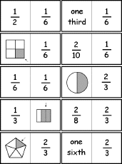  ½ | 1 ÷ 2  0.5 | 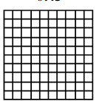  0.5 x 100 = 50%
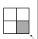
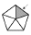
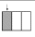
 |  | 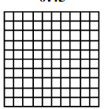

Fraction | Decimal | Percentage
3 ÷ 10

0.3
7 ÷ 10

0.7
0 1

0 1
0 1
40% same as 40
100

